**Save Guard Insurance Agency Missing sections report**

1. **Commercial Insurance**

* Sub Section under small business insurance is not available

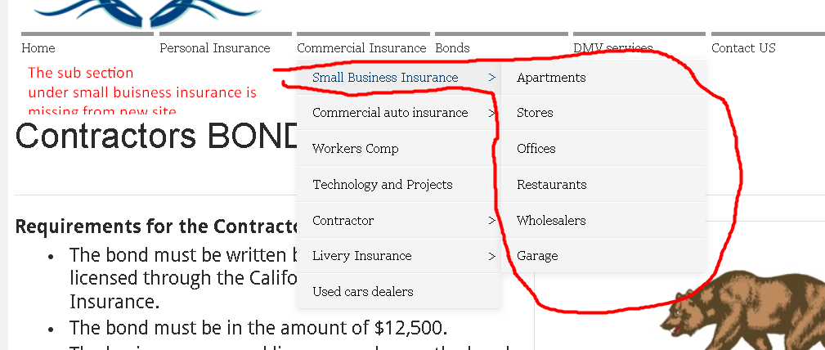

* Sub Section Under Commercial Auto Insurance is missing

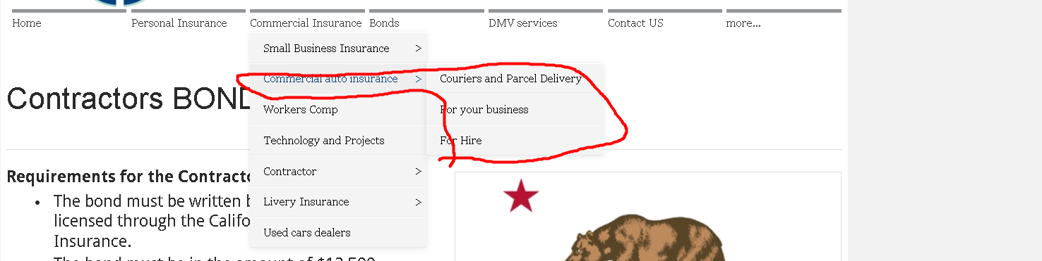

* Sub Section under Contractor is missing

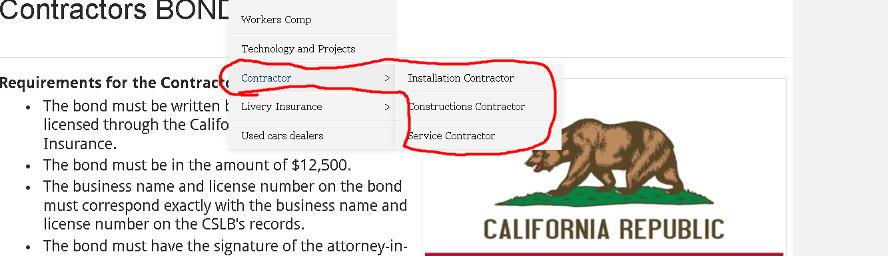

* Sub Section under Livery Insurance section is missing

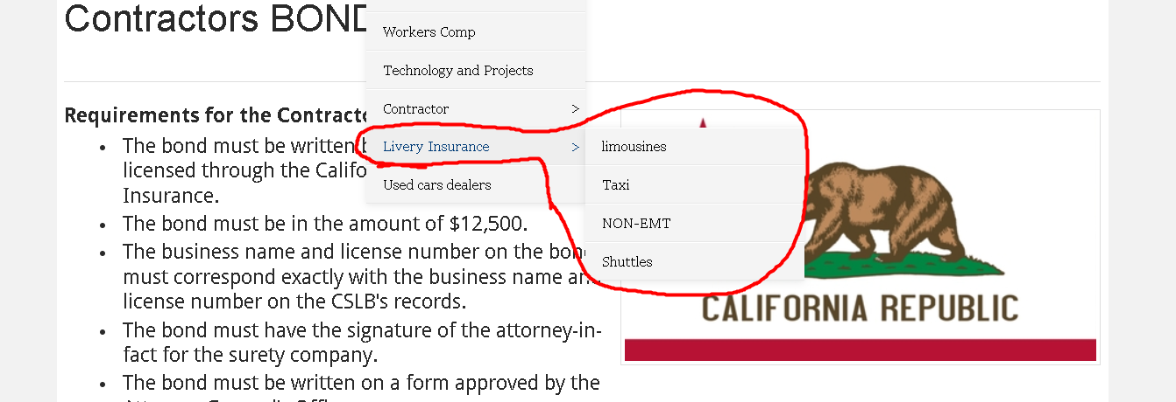

1. **Bonds Section**

Sub Section of Bonds is missing

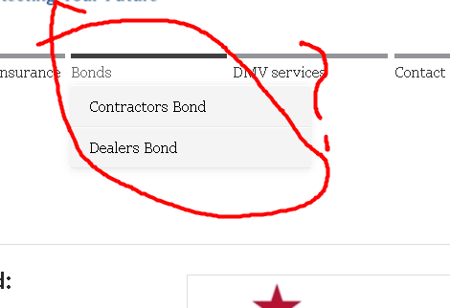

1. **DMV Services Section**

Sub section is missing

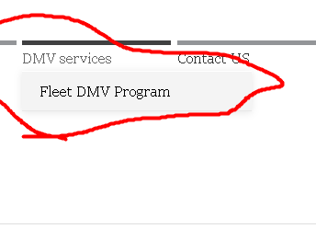

1. **More Section Missing along with Sub Section**

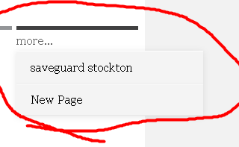

1. **Top Left logo doesn’t refresh the page or take me to the main page**

